    - Rise of Julius Caesar
      - 60 BC – Caesar joined forces with Crassus, a wealthy banker, and Pompey, a powerful general.
      - 59 BC- Caesar is elected consul forming the Triumvirate of Caesar, Pompey, and Crassus. Later Caesar is given an army in Gaul.
      - 58 BC to 50 BC Caesar, as governor of Gaul, leads his men in a campaign in the Gallic wars and invasion of Britain.
      - 53 BC – Crassus is killed in battle and Pompey jealous of Caesar’s success and popularity seeks out Senators to ruin Caesar.
      - Senate recalls Caesar to Rome. Caesar decides not to disband his army but instead march on Rome.
      - 49 BC Caesar crosses the Rubicon River. Pompey and many Senators flee to Greece. Caesar tracks them down and defeats their armies.
      - 46 BC: Senate acknowledges Caesar’s victory and appointed him as dictator for 10 years.
      - 44 BC - Caesar is named dictator for life.
      - Caesar’s reforms
        - Granted Roman citizenship to most of the provinces especially Gaul.
        - Expanded the Senate with
        - Began a public works program that provided employment for the poor and beautified Rome.
        - Gave veterans and lower classes land in the provinces.
      - Ides of March – March 15, 44 BC a group of Senators killed Caesar by stabbing him 23 times.
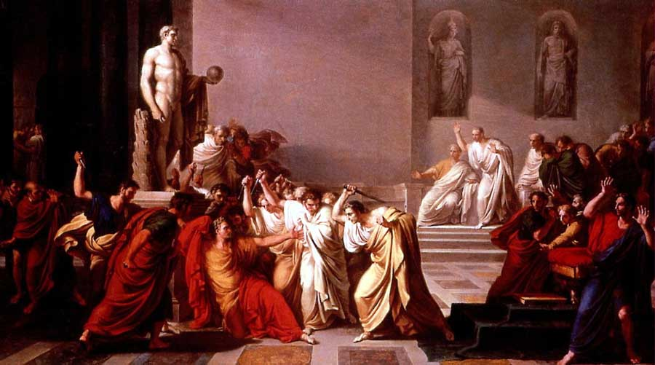
Caesar being assassinated in the Senate

